Downloaded github for windows.

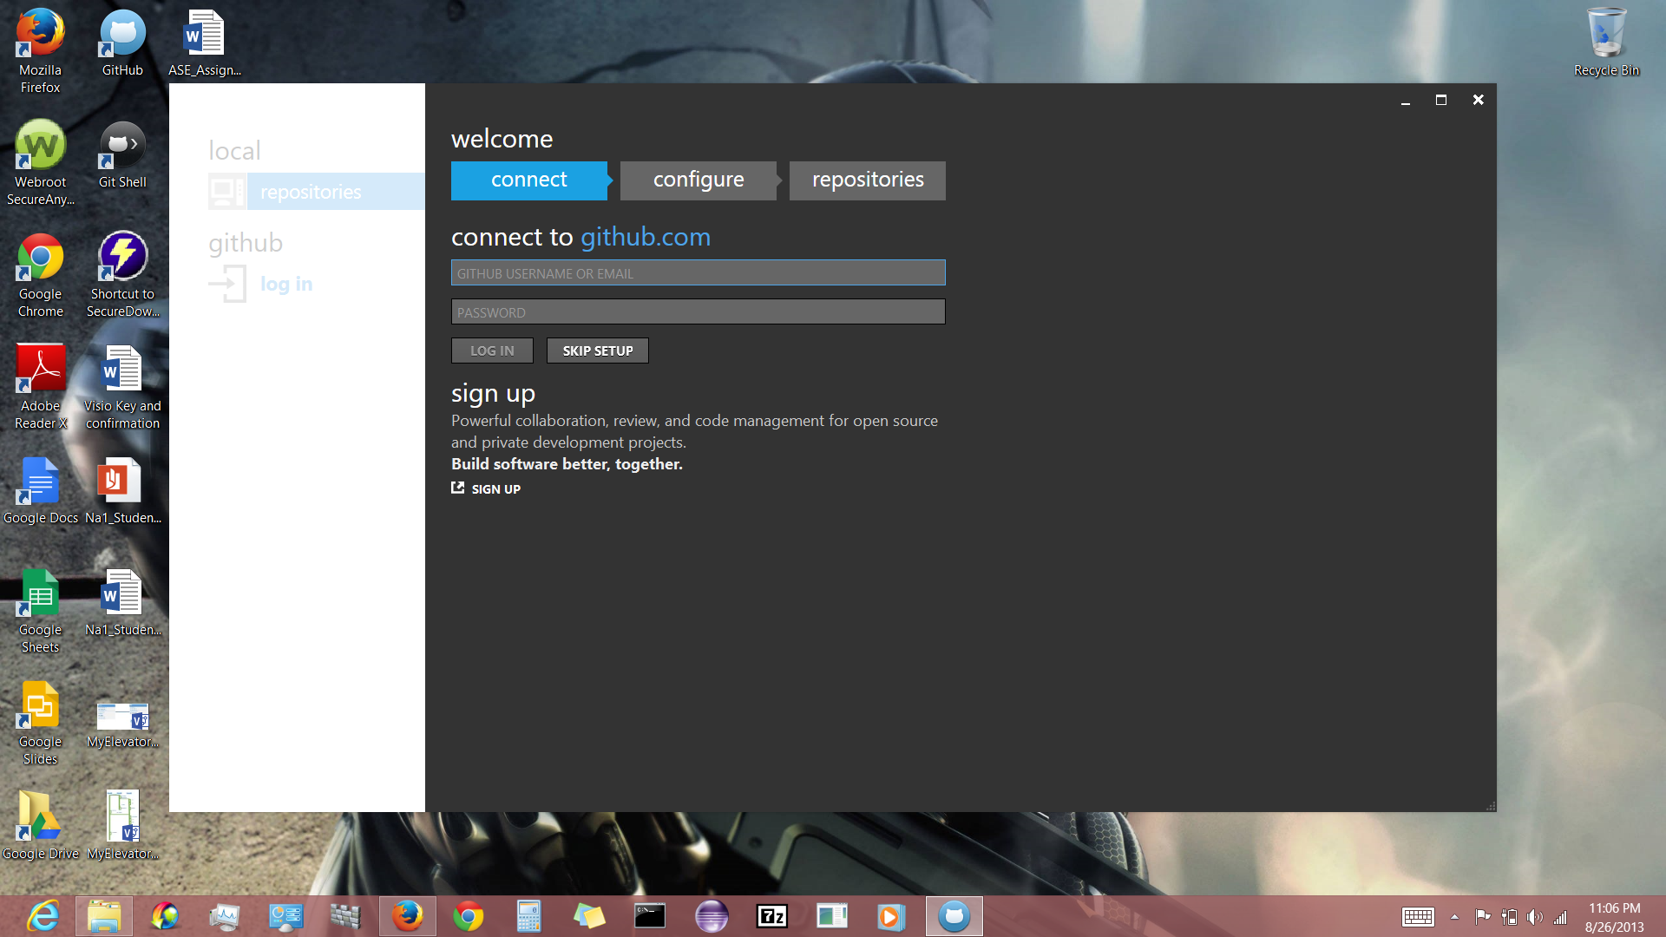

Created a github account ‘arf62’ and successfully logged into the local github on my machine.

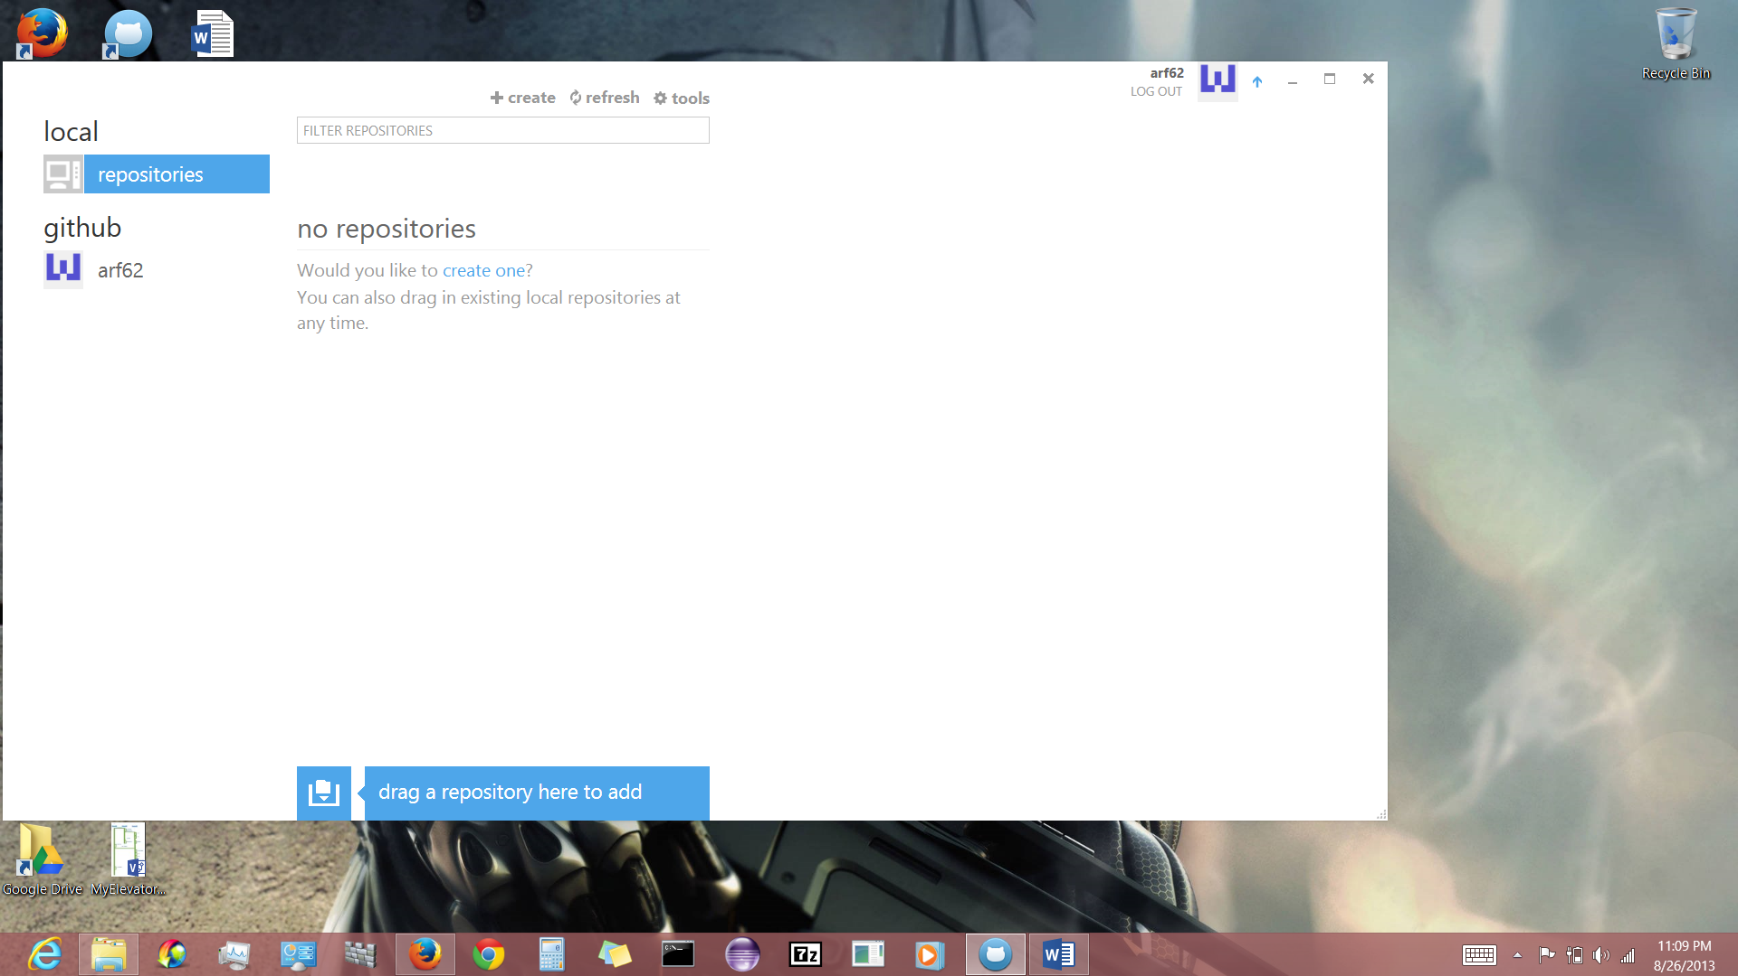

My online github account.

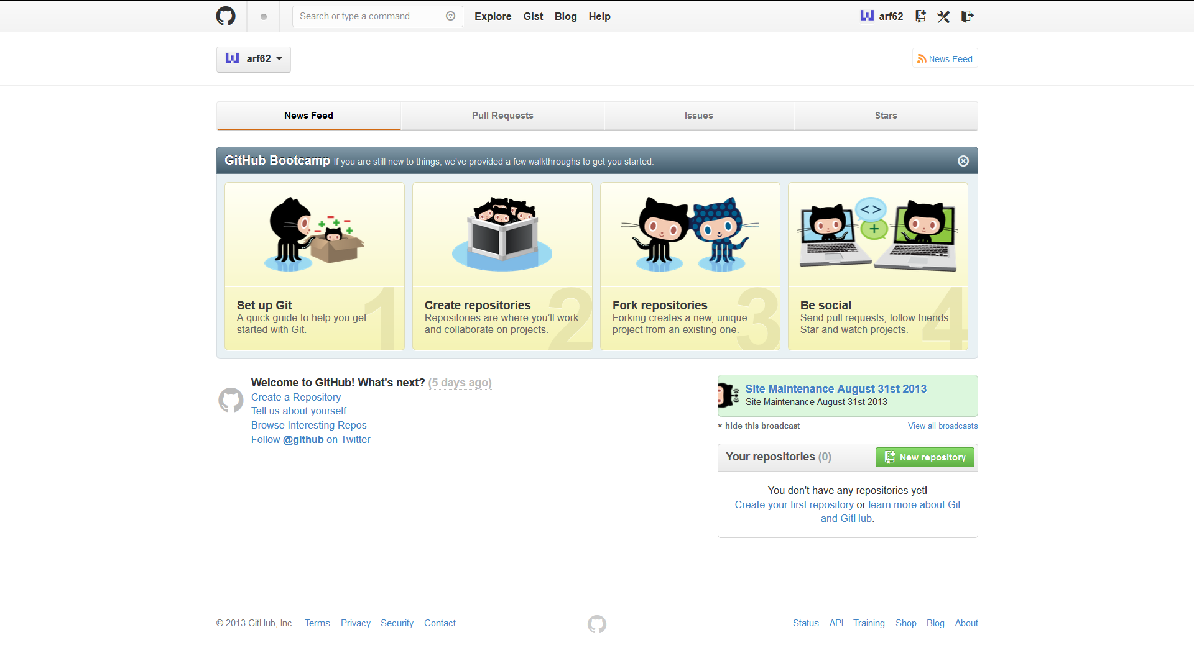

In the following screen shot , successfully created a test repository.

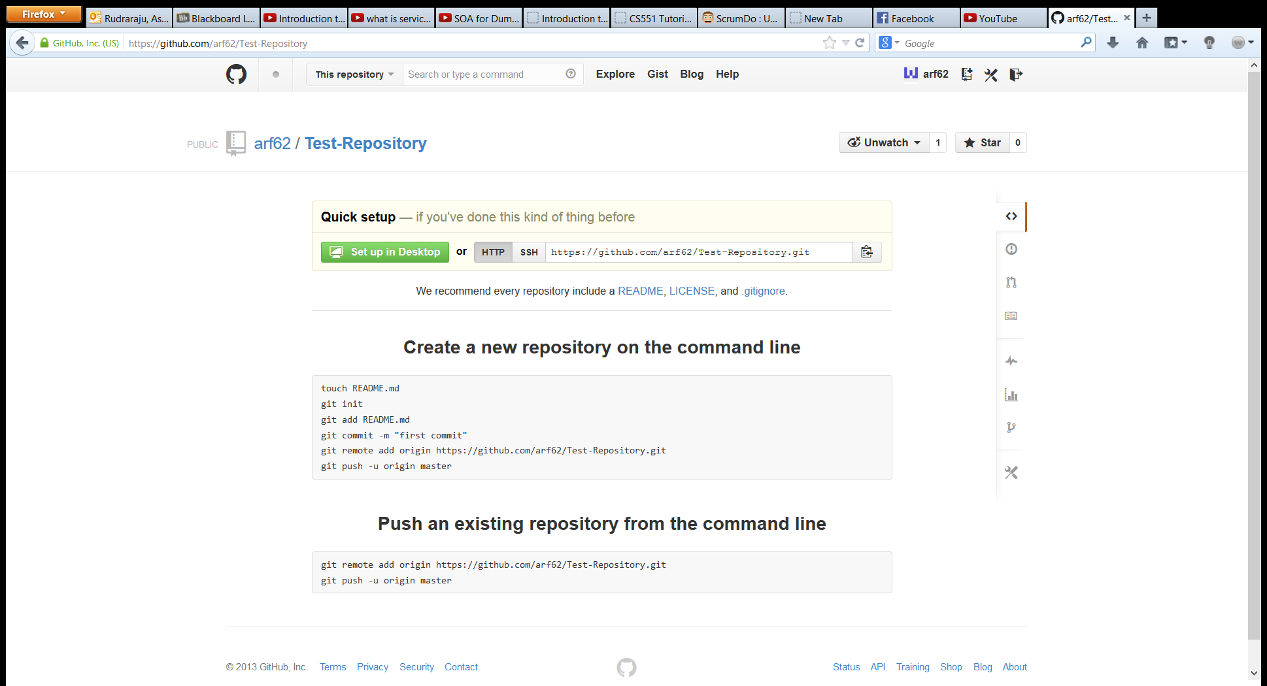

Successfully cloned the test repository on to my machine as shown in the following screen shots.

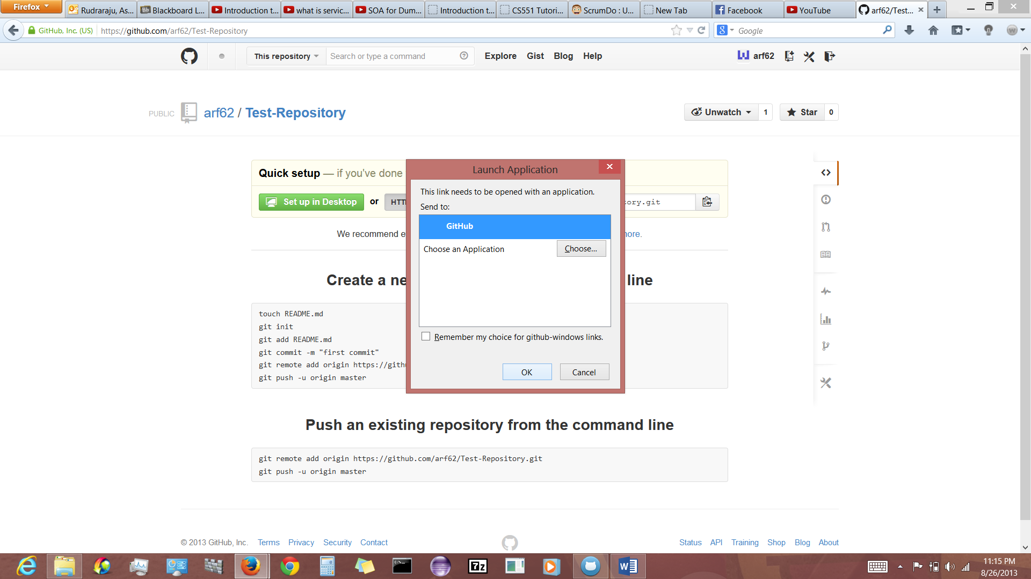

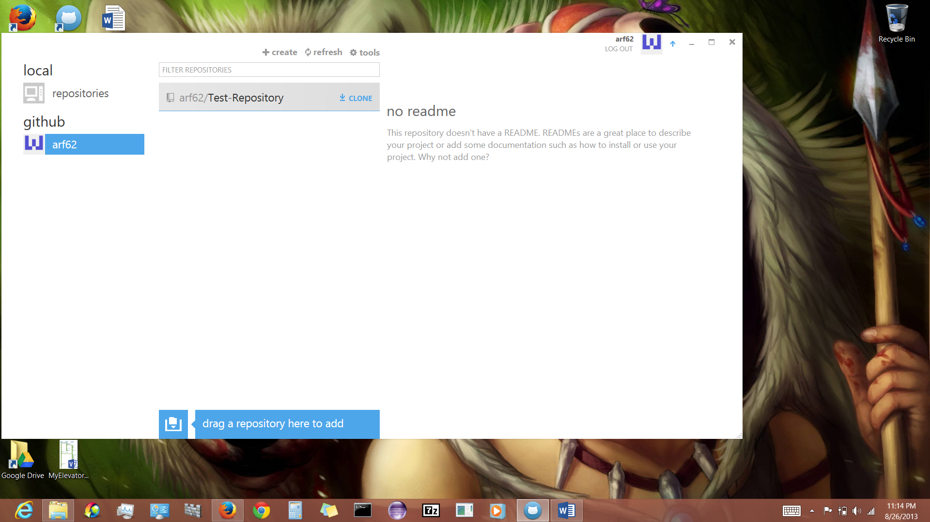

Made changes to the ‘hi.txt’ as shown in the following screen shots.

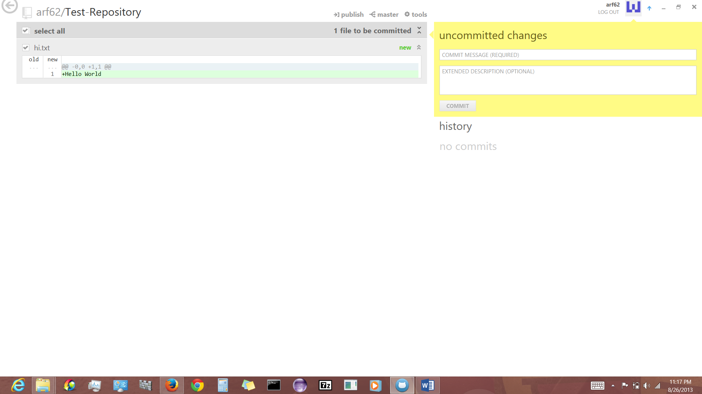

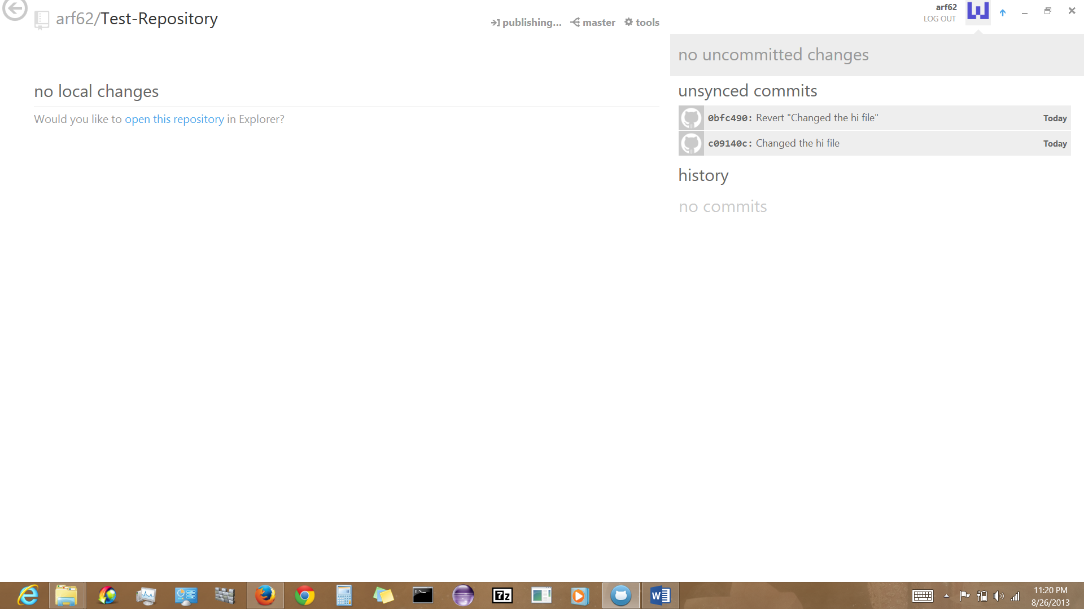

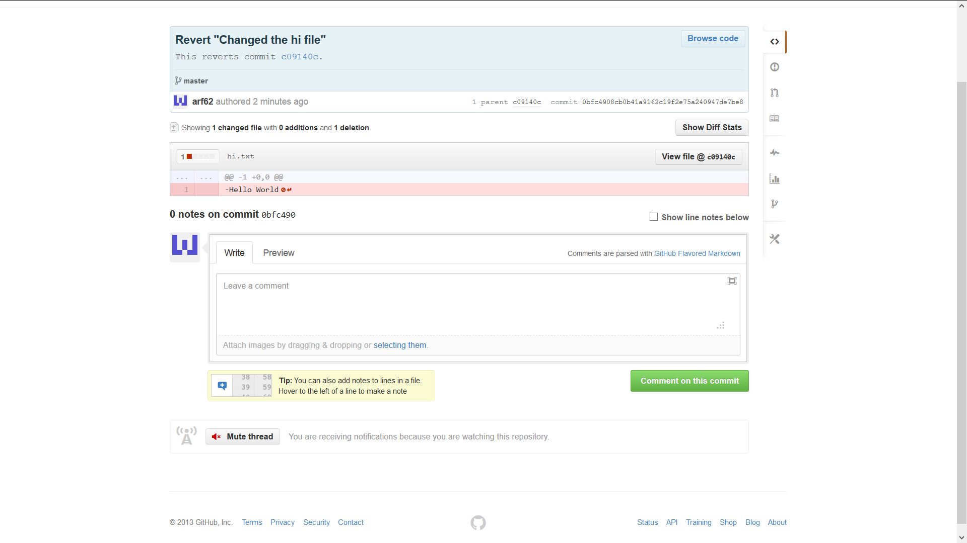

Created an organization ‘Umkc161’ as shown in the following screen shots.

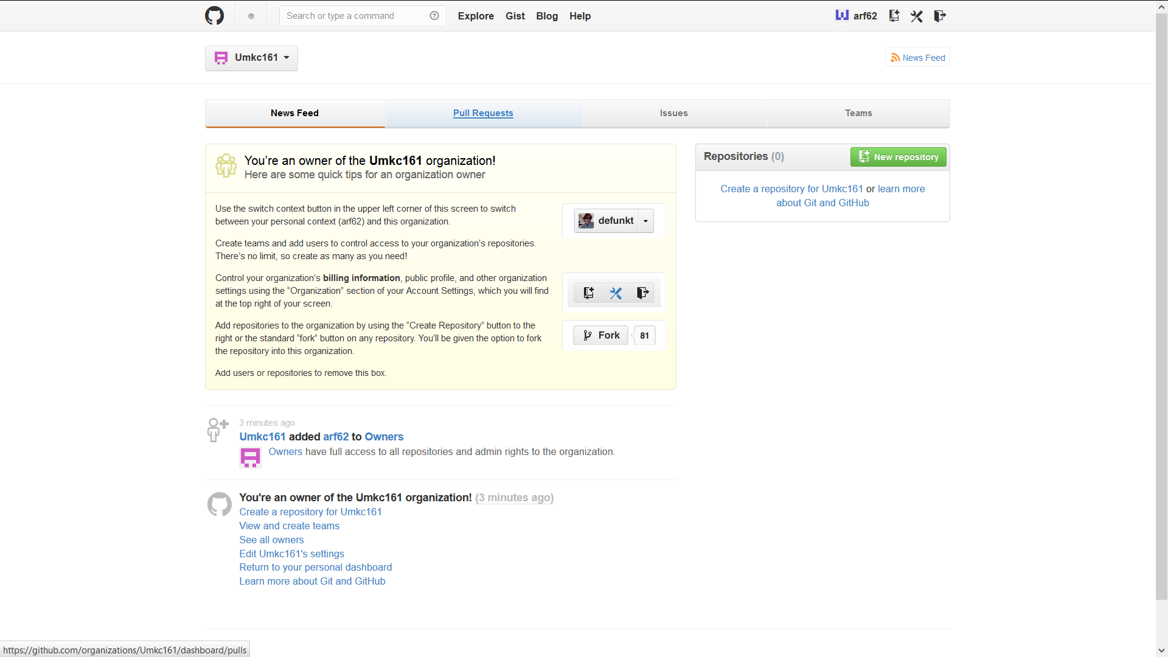

Created a repository named ‘Umkc-Test1’ under the organization ‘Umkc161’ and added a text file named ‘hello world’locally.

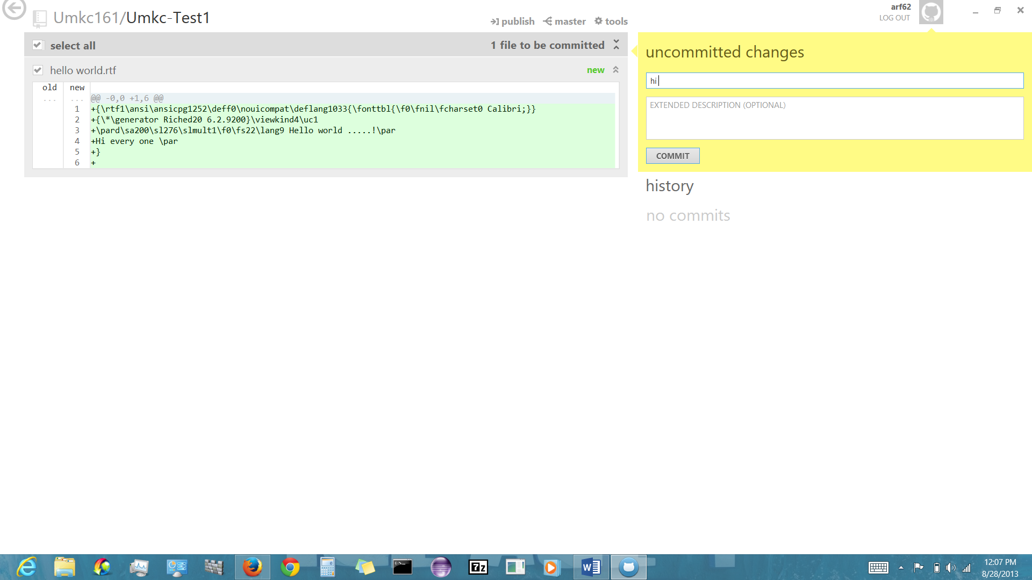

In the following screen shots created a team named ‘Dev Team’ in ‘Umkc161’ added my friend Alex as a team member and added the ‘Umkc-Test1’repository to the team.

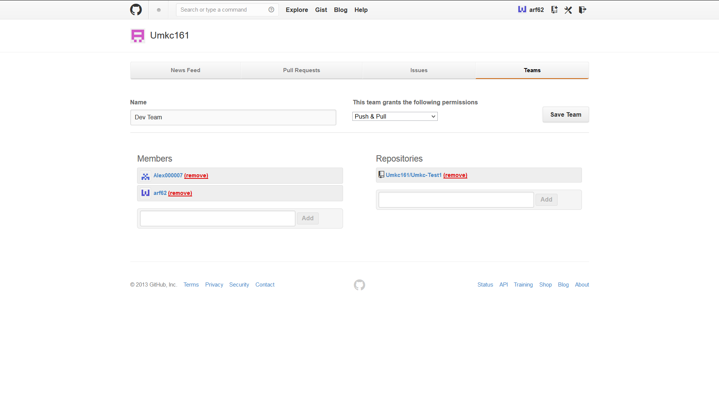

In the following slides Alex is trying to clone the repository on to local machine and try to edit and then sync the ‘hello world’ file.

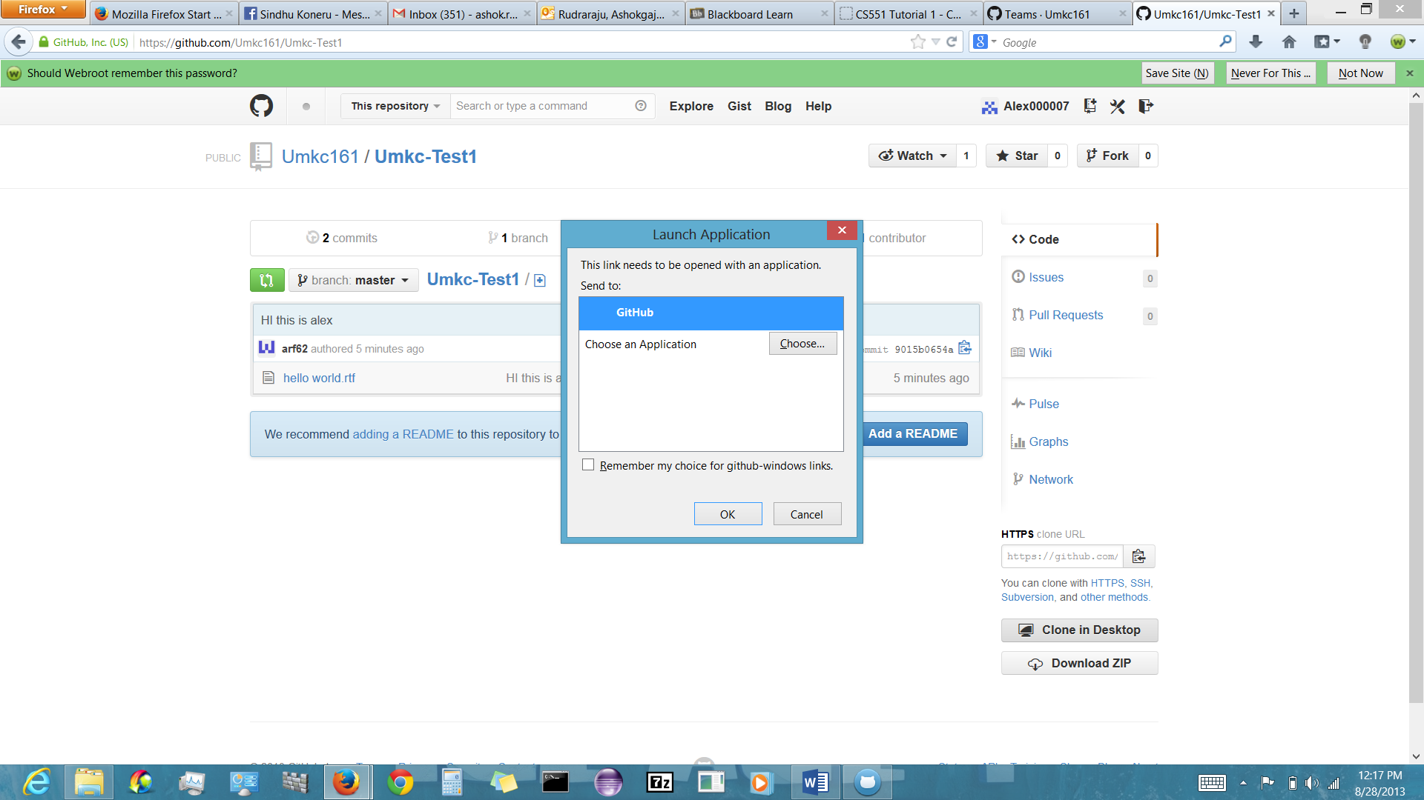

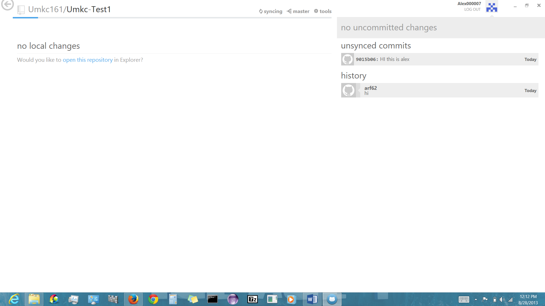

The following screen shot shows the changes synced by alex when I login.

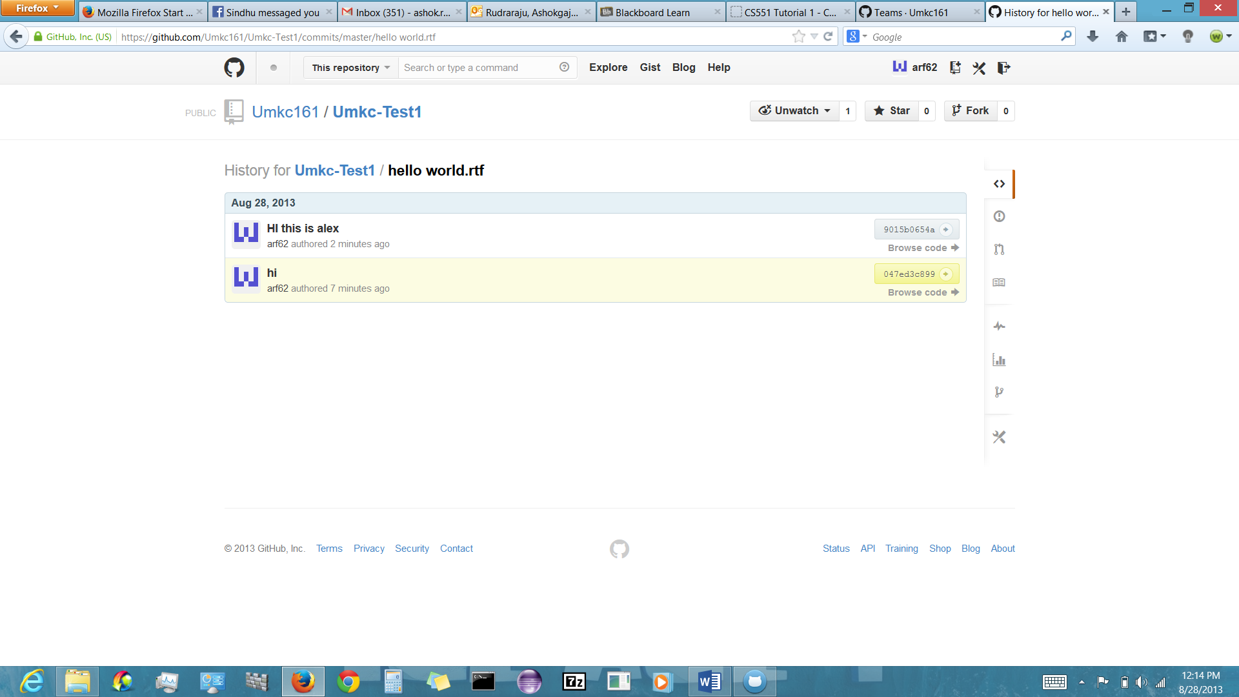

The following screen shot shows the overall changes and actions.

